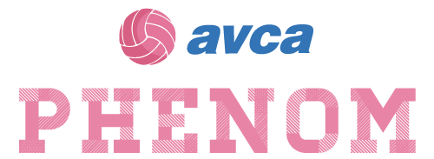
2020 AVCA Phenom College Preparatory Program - Omaha, NE

River City Juniors Volleyball Complex
11934 Portal Road
LaVista, NE 68128

FRIDAY, DECEMBER 18th, 2020
4:00 PM – 7:00 PM |  | Registration  Packet pick-up for Phenoms arriving on Friday

SATURDAY, DECEMBER 19th, 2020
8:00 AM – 9:00 AM | Registration  Packet pick-up for Phenoms arriving on Saturday
9:00 AM – 11:00 AM | Showcase Wave 1: Bib #’s TBD: - Phenoms Only
12:00 PM – 2:00 PM | Showcase Wave 2: Bib #’s TBD: - Phenoms Only
2:15 PM – 4:15 PM | Showcase Wave 3: Bib #’s TBD: - Phenoms Only

